**Ex. 2. Design a website using HTML5 [Form Elements + Media Elements] URK17CS127**

**Date:**

Build a site that conforms to HTML5 standards and has the following elements: div, p, headings, image, anchor, table ,audio, video, iframe, form, input, select, progress, fieldset, label, embed..

1. Your site consists of three pages. First page is a Home page. Second page has a form

for the students to admit in Karunya University. Third page add the academic calendar pdf file using embed element.

Guidelines for designing the First Page :

2. First page has three sections such as header, Content section and footer.

3. Header (or masthead) should be at the top of the page. It contains the university name.

Below the title include the navigation links and search box as shown in the mockup screen.

4. Content section has two columns. Display the dummy text in the First column. Add

background music to your page using the audio and it will play automatically as soon as the page loads without stopping. Embed the video in the second column using video tag and enable the controls.

5. A footer that goes across the bottom of the site and contains the google map.

Guidelines for designing the Second Page :

6. Second page contains a form to collect the applicant details.

7. Design a form with an action value of submit.php and method value of ”post”. Code the form with auto complete active. validate the form fields according to these validation rules:

All fields in the form are Required fields and it should not be empty

Name field you create should have autofocus, placeholder text, and be required.

The Application number field should have placeholder text, a pattern to restrict entry, and be required. The format is KU2017CSEXXXXX.

Password field should have at least 6 characters.

The mobile number field should have placeholder text, a pattern to restrict entry.

Phone Number is either only 10 numbers.

The Email address field should have placeholder text. This field should also be required. Mail address in the format xxxxxxxx@karunya.edu.in

Limit the user to choose only image file. Prevent them from choosing files of any

type or extension.

**Mockup page:**

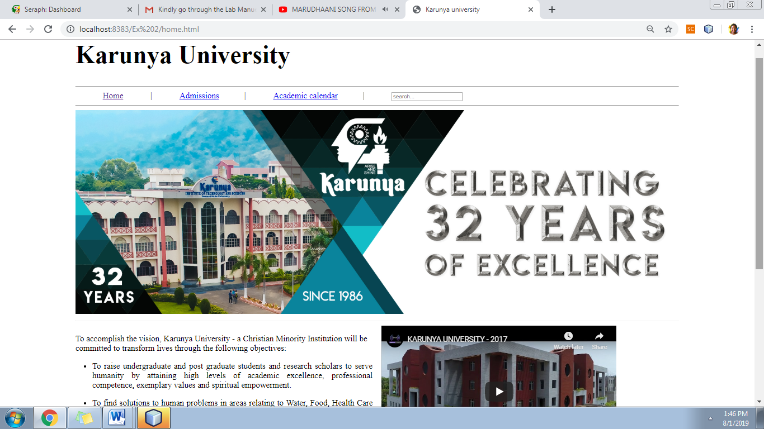

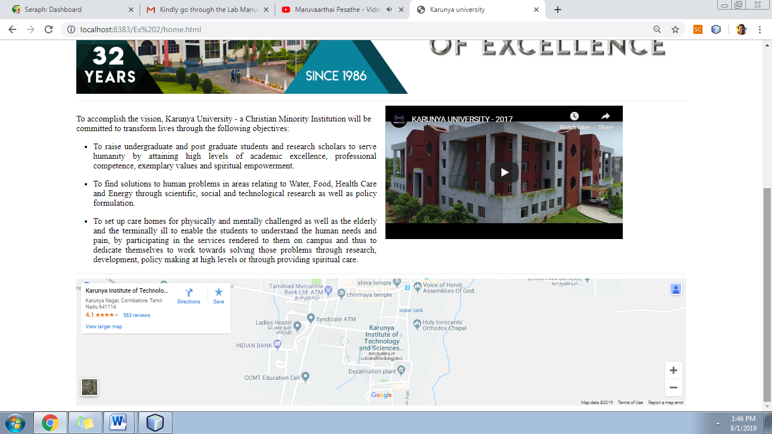

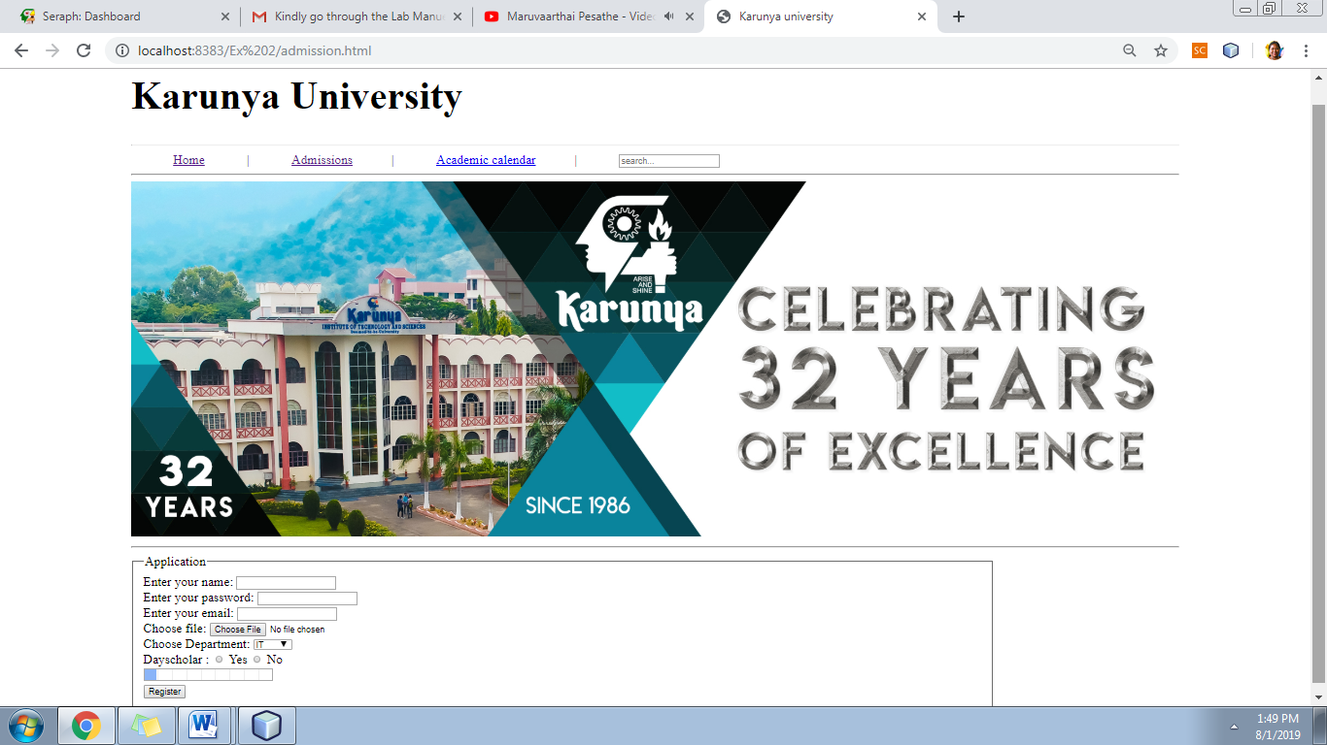

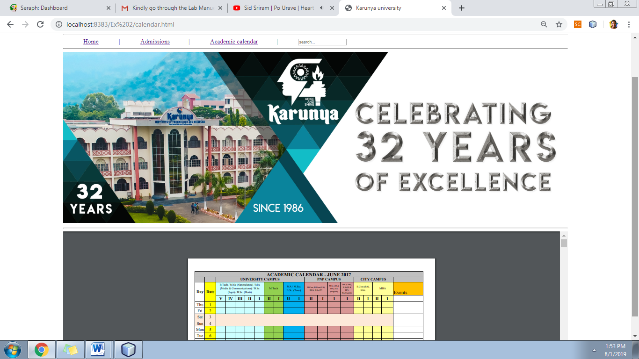

**Web site URL:** <http://urk17cs127.rf.gd/Exercise2/>

**You tube URL:** [**https://youtu.be/ZkJ7sXRfO8A**](https://youtu.be/ZkJ7sXRfO8A)